Cover


Tailings Management Area Decommissioning As-Built Report, Sä Dena Hes Mine, Yukon
Sä Dena Hes Project, Yukon Territory, Canada
Teck Resources Limited
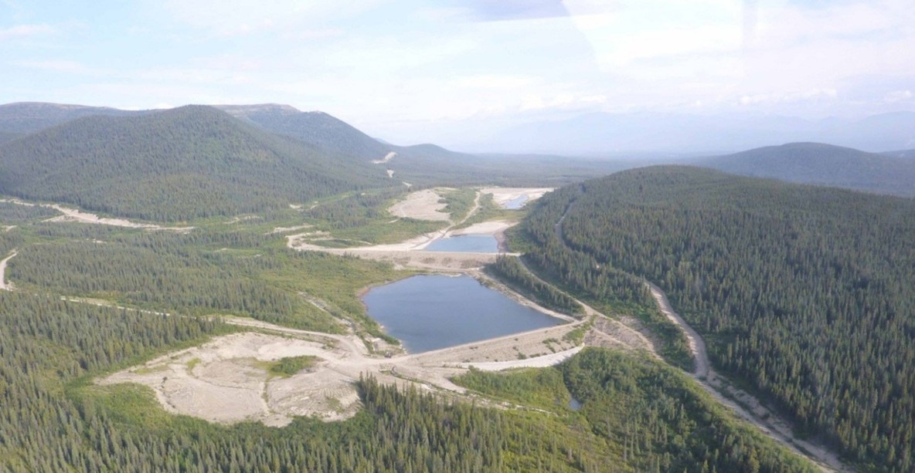
SRK Consulting (Canada) Inc. 1CT008.054 March 2015

Inside Cover
Tailings Management Area Decommissioning As-Built Report, Sä Dena Hes Mine, Yukon
Sä Dena Hes Project, Yukon Territory, Canada
Prepared for
Teck Resources Limited
601 Knighton Road
Kimberly, BC, V1A 3E1
Canada
+1 250 427 8408
www.tech.com
Prepared by
SRK Consulting (Canada) Inc.
2200-1066 West Hasting Street, Suite 2200
Vancouver, BC, V6E 3X2
Canada
+1 604 681 4196 Tel
www.srk.com
Acknowledgements
Lead Authors: Stuart McPhee Lead Reviewers: Peter Healey
Document Information
Project Number: 1CT008.054
Publication Date: March 2015
File Name: SDH_Dam_Decomissioning_AsbuiltReport_1CT008.054_SDM
Suggested Citation
SRK Consulting (Canada) Inc. 2015. Tailings Management Area Decommissioning As-Built Report, Sä Dena Hes Mine, Yukon. Vancouver, BC. Project number: 1CT008.054. Published March 2015. 7 pages, plus 2 appendices. Prepared for Teck Resources Limited.
Cover Photo Reference
Aerial view of Sä Dena Hes Mine
Copyright ©SRK Consulting (Canada) Inc., 2025

Contents
Definitions iv
Executive Summary v
1 Introduction 1
1.1 Background 1
1.2 Closure Objectives 1
1.3 Project Participants 1
2 Decommissioning Plan 3
Signatures 5
References 6

Tables
Table 1.1 Summary of Project Participant Roles and Responsibilities 2

Figures
Figure 2.1 Sä Dena Hes Tailings Management Facility 9

Appendices
Appendix A Photo Log

Definitions
This list contains definitions of symbols, units, abbreviations, and terminology that may be unfamiliar to the reader.
SRS | sediment retaining structure
TMA | tailings management area

Executive Summary
The Sä Dena Hes Mine, located near Watson Lake, Yukon, was permanently closed in 2013 due to low metal prices. Teck Resources Limited engaged SRK Consulting (Canada) Inc. to develop and oversee the decommissioning of the Tailings Management Area (TMA), executed between April and October 2014. The project aimed to protect public health and safety, implement environmental protection measures, and ensure land use compatibility with surrounding areas. Key activities included dewatering ponds, removing dams, constructing a sediment retention structure, realigning Camp Creek, and placing till covers over exposed tailings.
Several design modifications were made during construction to address field conditions, such as adjusting the sediment retention structure elevations and re-aligning drainage channels. A rock cofferdam was constructed to stabilize tailings in the South Pond. Post-construction monitoring is recommended to ensure the long-term stability and effectiveness of the decommissioning measures, focusing on geotechnical inspections, vegetation monitoring, and geochemical assessments.
The decommissioning successfully met closure objectives, with significant improvements to surface water management systems and 155,081 m² of tailings cover constructed. Challenges such as seepage and tailings instability were mitigated through adaptive construction techniques, positioning the site for long-term passive monitoring and eventual integration with surrounding land use.

Introduction

Background
The Sä Dena Hes property is located close to the Yukon’s southern border with British Columbia, approximately 70 km north of the town of Watson Lake traveling on the Robert Campbell Highway (Figure 1). In 1994, the current property owners (joint venture between Teck Metals Limited, Teck Resources Limited, and Pan Pacific Metal Mining Corp., a subsidiary of Korea Zinc) purchased the property through a court ordered receivership. In 2013, the owners made the decision to permanently close the mine due to low metal prices.
In accordance with the overall site closure plan (Teck 2013) of the Sä Dena Hes mine (Figure 2), the tailings management area (TMA) would no longer function as it has for the last 34 years and therefore two of the dams could be removed and changes could be made to the surface water management systems. SRK Consulting (Canada) Inc. was retained by Teck to develop a decommissioning plan for the TMA, which included the removal of the South and Reclaim Dams, the relocation of the existing Camp Creek Diversion to its original creek alignment, a sediment retaining structure (SRS) at the toe of the removed South Dam, ancillary riprap lined drainage channels, and the placement of a till cover over the deposited tailings that would remain stored on site behind the North Dam (Figure 3).

Closure Objectives
The decommissioning of the TMA was carried out in accordance with Teck’s corporate closure guidelines which include:
- Protection of public health and safety
- Implementation of environmental protection measures to prevent adverse impacts
- Ensuring land use commensurate surrounding lands
- Post closure site monitoring to assess effectiveness of closure measures for the long-term
- Passive post closure monitoring and management of the site where possible

Project Participants
Teck Resources Limited served as the owner of the Sä Dena Hes legacy property. AMEC-FW was responsible for continuous construction monitoring and project management services for Teck. Services included the production report, daily and weekly reports, photo logs, material quantity tracking, and contract management during the construction period.
SRK was responsible for the design of the works detailed in the decommissioning design report (SRK 2014b). SRK was also responsible for a component of the water quality data collection and the training field staff to collect water quality samples.
Cobalt was the prime contractor responsible for the decommissioning work on the TMA.
A list of the companies that worked on various aspects of the TMA decommissioning are provided in Table 1.
Table 1.1 Summary of Project Participant Roles and Responsibilities
Name | Location | Roles and Responsibilities
Teck Resources | Kimberly, BC | Owner
Amec Foster Wheeler | Fredericton, NB | Construction management services
SRK Consulting | Vancouver, BC | Design engineering and environmental
Liard First Nation Development Corp. | Watson Lake, YT | Environmental
Cobalt Construction | Whitehorse, YT | Contractor - Earth Works

Decommissioning Plan
SRK prepared the TMA decommissioning plan (SRK 2014b) that was implemented between April 19 and October 14, 2014, and included the following:
- Dewatering Reclaim and South Pond in accordance with the existing water license discharge limitations (not to exceed 228 m3 per hour or a quantity of 490,000 m3 over a cumulative period of 90 days)
- Removal of the South and Reclaim Dam with the North Dam remaining in place
- Removal of the South Dam emergency spillway, decant tower, and the decant pipe that was installed through the dam
- Excavation of material from the removal of the South and Reclaim Dams as source material to cover tailings
- Placement of a till cover over tailings deposited behind the North Dam and in the South Pond

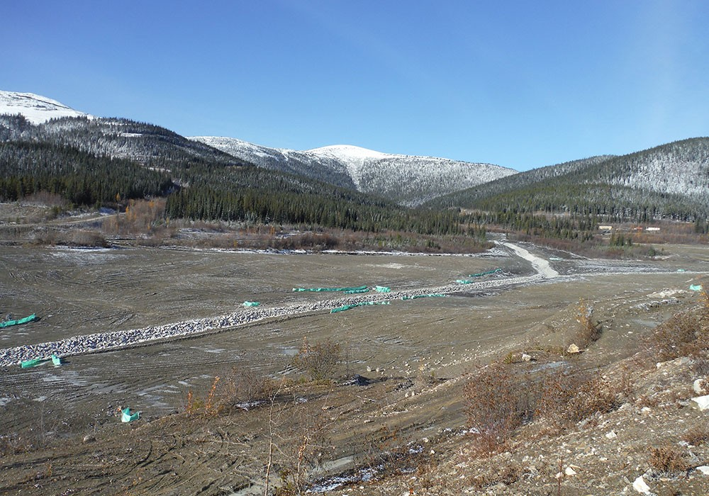
Source: https://cobaltconstruction.ca/projects/featured-projects/sa-dena-hes-tailings-management-facility-decommissioning/
Figure 2.1 Sä Dena Hes Tailings Management Facility
Notes: Construction activities for tailings decommissioning

Signatures
This report was prepared by
Stuart McPhee, EIT
Staff Consultant

and was reviewed by

Peter Healey, PEng
Principal Consultant

All data used as source material plus the text, tables, figures, and attachments of this document have been reviewed and prepared in accordance with generally accepted professional engineering and environmental practices.
Disclaimer. SRK Consulting (Canada) Inc. has prepared this document for Teck Resources Limited, our client. Any use or decisions by which a third party makes of this document are the responsibility of such third parties. In no circumstance does SRK accept any consequential liability arising from commercial decisions or actions resulting from the use of this report by a third party.
The opinions expressed in this document have been based on the information available to SRK at the time of preparation. SRK has exercised all due care in reviewing information supplied by others for use on this project. While SRK has compared key supplied data with expected values, the accuracy of the results and conclusions from the review are entirely reliant on the accuracy and completeness of the supplied data. SRK does not accept responsibility for any errors or omissions in the supplied information, except to the extent that SRK was hired to verify the data.

References
AMEC-FW. 2014 Reclamation Activities and As-Built-Report (DRAFT). Teck Resources Limited - Legacy Properties Sä Dena Hes Mine Decommissioning and Reclamation.
SRK. 2014a. Sä Dena Hes Quarry Development Plan. Prepared by SRK Consulting (Canada) Inc. March 2014.
SRK. 2014b. Sä Dena Hes Tailings Management Facility Decommissioning Design Report. Prepared by SRK Consulting (Canada) Inc. April 2014.

- Photo Log
This appendix includes photos taken during surveying at the site from the previous fall, September and October 2014.

